|  |
| --- |
|  |



**28 December 2012** **The Weekly Bulletin of Rotary Club of Kathmandu Mid-Town** **Bc-28.12/012-13**

District : 3292 Web:www.rotarymidtown.org.np Club Id : 26776

**DECEMBER IS THE FAMILY MONTH**

**The RI Board has adopted the following statement on family:**



**The Board, recognizing that**

• The family, which is the basic unit of society in the community, is struggling with a host of complex social and economic problems that are attacking its structure

• In many parts of the world, this breakdown of the traditional structure is, in turn,

threatening the fabric of community life

• Rotary's longtime commitment to Community Service makes it imperative for Rotarians to actively address the crisis in the family today

• Encourages Rotarians, Rotary clubs, and districts worldwide to:

- Bring their power to bear through existing programs on the most formidable problems facing families today, including but not limited to domestic violence, child abuse and neglect, homelessness, drug and alcohol abuse, gang activities, child-care needs, and underemployment;

- Instill the importance of universal human values in the homes, schools and communities of the world;

- Continue current projects and undertake new ones that strengthen the family structure and make it a secure anchor for the larger community;

- Demonstrate their commitment to family and community through projects, activities, and events in celebration of "Family Month" each year.

*Source:*Rotary International News

**Happy New Year 2013**

  

**Friday, 21 December:**

**Third Club Assembly of the Rotary Year 2012-13**

During the Club Assembly Chairpersons of the permanent committees presented progress reviews of activities and projects being carried out or implemented under the respective avenues – Membership development, Club administration, Public relations, Service projects, the Rotary Foundation and New Generation.

Club Members present posed for a group photo:

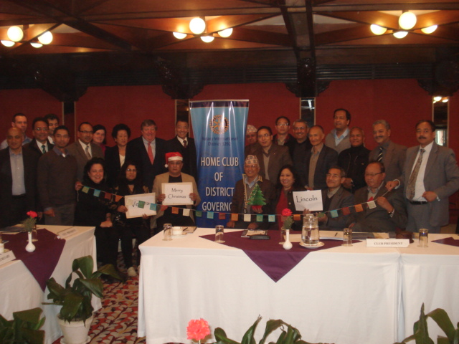

**Merry Christmas and**

**Happy New Year**

to

all Rotarians, their spouses, children, relatives, friends and all near and dear ones.

# Weekly Meetings and Programs :

|  |  |  |
| --- | --- | --- |
| Date | Program/Speaker | Program/Topics of Presentation |
| 28 Dec 2012 | Club Holiday | No meeting |
| 4 Jan 2013 | Dr Rabindra Shrestha | Nepal cultural role in the Indian Subcontinent |
| 11 Jan 2013 | HE Asko Luukkainen,  Ambassador of Finland | Nepal-Finland Relations |

**Friday, 28 December:**

Club Holiday. No weekly meeting. Enjoy - NEW YEAR CELEBRATION

Wishing you all a very



*2 0 1 3*

**Project/Program Visits:**

Gorkha/Lamjung Girl Child Project visit program now rescheduled for 25 and 26 January 2013. For registration, contact PP Pratap Malla at [pratapmalla@yahoo.com](mailto:pratapmalla@yahoo.com) or at 9841270293 or at 4271792.

**December is Family Month:**

It is often said that children are the future of the world. Healthy and happy children are key to achieving Rotary's goal of building international understanding and peace in the world. There is no better place to nourish a young mind than in a family whose basic needs have been met and who can spend time together.

Celebrate Rotary's commitment to family in December.

Consider bringing together the mothers, fathers, children, uncles, aunts, grandparents, cousins, and members of your Rotary family into shared activities.

Participate in a community service project that will help strengthen families in your community by:

- Sponsoring a seminar for new parents on child development;

- Organizing a father/daughter or mother/son dinner;

- Promoting a family literacy project which emphasizes parents reading to their children;

- Raising awareness of child abuse prevention programs in your community;

- Chaperoning a safe and fun weekend activity for the community's teenagers;

- Volunteering at a shelter for homeless families;

- Assisting the elderly in nursing homes with simple crafts that they can give as gifts to their families;

- Creating a park or recreational area where parents can spend time with their children;

- Providing materials and support to a daycare facility or orphanage;

- Creating an after-school activities program for older children which will give them a safe place to go while their parents are at work.

*Source:* RI News

**Future Vision :**

**Global Grants :** Rotary Foundation Global Grants support large international activities with sustainable high-impact outcomes in one or more of the six [areas of focus](http://www.rotary.org/en/Members/RunningADistrict/FutureVisionPilotProgram/Pages/AreasofFocus.aspx)  and have a long-term impact. Clubs and districts can either create their own activities or sponsor [packaged global grants](http://www.rotary.org/en/Members/RunningADistrict/FutureVisionPilotProgram/Pages/fv_packaged_global_grants.aspx)  that are developed by The Rotary Foundation in cooperation with its strategic partners.

**Club- and district-developed global grants:** Clubs and districts can use [District Designated Fund (DDF)](http://www.rotary.org/en/Contribute/Funds/SHARE/Pages/ridefault.aspx)  or cash contributions to fund global grant activities and get matching funds from the Foundation. When developing activities, clubs and districts should consider the following:

Activities must be [sustainable](http://www.rotary.org/RIdocuments/en_pdf/fv_global_grants_sustainability_principles_en.pdf)  and measurable. For example:

How will a project benefit the selected community in the future, after the grant has been spent?

How will a scholar's studies support one or more of the areas of focus?

How will a vocational training team project support capacity building, either for the team or the benefiting community?

Activities should stem from real community needs. [Community needs assessment tools](http://www.rotary.org/en/serviceandfellowship/startaproject/Assessments/Pages/ridefault.aspx)  are available to help identify community needs.

Global grants must be sponsored by two Rotary clubs or districts: a host partner in the country where the activity takes place and an international partner outside the country. Both partners must be Future Vision pilot members.

Both partners must be actively involved in the planning and implementing of all global grants. This includes maintaining communication and developing plans for the shared responsibilities in all of the grant's stages.

**Funding:** The minimum award amount from the World Fund for a global grant, regardless of activity type, is US$15,000, which results in a minimum total financing of $30,000. The World Fund award is based on a 100 percent match of DDF ($1.00:$1.00) or a 50 percent match of cash contributions ($0.50:$1.00).

**Applications:** All Rotary Foundation Global Grant applications will be accepted on a rolling basis throughout the year. A two-step online application process is accessible via [Member Access](http://www.rotary.org/en/selfservice/Pages/login.aspx) . Additional documentation for [scholarships](http://www.rotary.org/RIdocuments/en_doc/fv_global_grants_scholar_application_en.doc)  and [vocational training teams](http://www.rotary.org/RIdocuments/en_doc/fv_global_grants_vtt_participant_application_en.doc)  must be completed by non-Rotarian participants; the grant sponsors will upload these items electronically to the application.

For club- and district-developed global grants, Rotarians will submit a brief online proposal before submitting a formal application. The proposal should provide an overview of the grant activity's objectives and demonstrate how the activities fit within an area of focus. This process is designed to increase the acceptance rate of grant applications.

Once a proposal has been accepted, Rotarians will submit an online application that provides the Foundation with more detailed grant activity and budget information. (Depending on the award amount or complexity of the project, the Foundation may request additional details.) Applications requesting a World Fund award (match) of more than US$100,000 will be reviewed by the Trustees quarterly. The following dates will be used to determine at which Trustee meeting applications will be reviewed:

Complete applications received by1 June will be reviewed by the Trustees in September; 1 October will be reviewed in January; 1 December will be reviewed in March; 1 February will be reviewed in May.

Once an application has been approved by the Foundation, both sponsors have authorized the agreement, and all associated cash contributions have been received, the Foundation will issue a payment.

Reports showing measurable success of the grant activity will be due to the Foundation every 12 months from the first issued payment. A final report is due when the grant funds have been completely spent and the objectives of the activity have been met.

**Types of activities:** Global grants support a variety of activities based on the needs of the benefiting communities or participants. All grant-funded activity must follow the eligibility requirements in the [Terms and Conditions for Rotary Foundation District Grants and Global Grants](http://www.rotary.org/RIdocuments/en_pdf/fv_grant_terms_conditions_en.pdf) . The grant structure is designed to allow clubs and districts more flexibility in creating grants that will further the [mission of The Rotary Foundation](http://www.rotary.org/en/AboutUs/TheRotaryFoundation/Pages/ridefault.aspx)  within the areas of focus.

Global grants may be used to fund humanitarian projects, provided that they

- support the goals of one or more of the areas of focus,

- produce measurable outcomes in the benefiting community,

- achieve results that can be sustained after the grant funds have been expended,

- have been developed in conjunction with the benefiting community to address their most pressing needs,

- seek to address community needs in an integrated manner.

Global grants may be used to provide funding for academic studies provided that they

- fund graduate-level study that relates to one or more of the areas of focus,

- fund studies for a term of one to four academic years,

- sponsor the academic studies of an individual traveling from the international sponsor district to the host sponsor district.

Global grants also may support vocational training teams, which are groups of professionals traveling abroad to either learn more about their profession or teach local professionals about a particular field. They

- may build the capacity of either the team itself or a specific benefiting community,

- may be carried out in conjunction with a humanitarian project or scholarship,

- may be multi-vocational but must share a common purpose in support of the selected area of focus,

- must consist of a minimum of one Rotarian team leader and three non-Rotarian team members with no maximum limit of participants,

- have no restrictions on participant age or length of time for training,

- permit one or more teams to travel under each grant.

*Sustainability will be a major focus under Future Vision, as we shift our emphasis to long-*

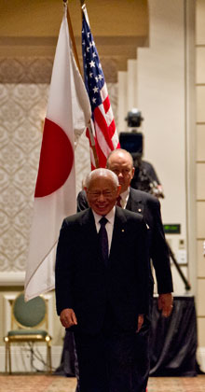

*term, high-impact projects. Simply put, a sustainable project is one that will continue to*

*benefit the world even after Rotary funding ends. A truly sustainable project requires an*

*emphasis on planning and cooperation, a long-term perspective, and an approach that*

*considers community members as partners in our service, not passive recipients.*

**RI President Sakuji Tanaka**

On Lighter Side :

Click here ⇩



**A Thought for the Day:**

***Some people always throw stones in your path.***

***It depends on you what you make with them - wall or bridge?***

***Remember you are the architect of your life.***

**Great Quotes:**

*To be humble with superiors is duty, to equals, courtesy, to inferiors, nobleness.*

- Benjamin Franklin

**Number Game:**

*Answer to the last week's number game : 15+7= 330*

NB: If you have any information/photo that may be of interest to Rotarians send them to

BC Editor: RR Shrestha email: rryesrr@gmail.com

## 28 Dec 2012 The Weekly Bulletin of Rotary Club of Kathmandu Mid-Town bc-28.12/012-13